**Easy Ways to Deal with Toxic People**

August 13, 2015

<http://www.womenworking.com/easy-ways-deal-toxic-people/>

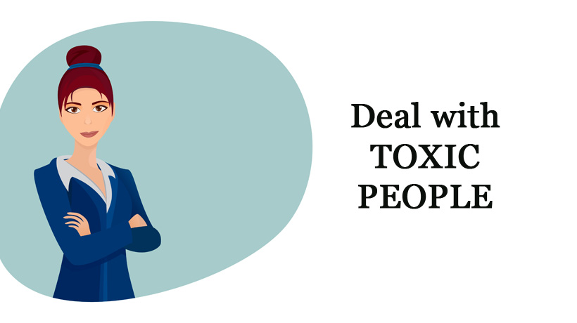

[](http://www.womenworking.com/profile/alan-allard/)

[Alan Allard](http://www.womenworking.com/profile/alan-allard/)

Executive Coach

If anything is true in life it’s that relationships can be challenging at times. For many people, one of the biggest challenges is dealing with someone who aggressively pushes you to do what they want, even if it’s not in your best interest. If you find yourself in that situation, here’s what you need to know and do:

**Know the warning signs:**

* They’re not making a request or a suggestion—they frame what they want you to do as an obligation on your part.
* They won’t let it go—they’re trying to wear you down.
* You’re feeling guilt, shame, or fear when you talk to them.
* They dismiss your feelings in the matter and accuse you of being too sensitive or difficult to get along with—or things similar to that.
* They threaten you in some way to get you to cave in.

In short, if you’re dealing with someone who refuses to respect your decisions, you’re almost certainly dealing with someone who doesn’t have your best interests at heart. After all, it’s always in your best interest to make decisions you feel good about. It’s never in your best interest to make decisions out of fear, guilt, or shame.

That’s what you need to know when dealing with someone who’s not acting in your best interest. Now, let’s look at what you need to do:

**Protect yourself:**

No one has a right to dismiss a clear “No” from you, much less to try to manipulate you through guilt, shame or fear. Don’t worry about convincing the other. Your priority is to protect yourself, not to make things easy on the other person.

Don’t worry about the relationship falling apart, and don’t give in to any fear you might have about not doing what the person wants. Failing to protect yourself will do more harm to you than anything they can do.

**Keep your emotions in check:**

Dealing with someone who isn’t taking your best interest into consideration can be anywhere from unpleasant to gut-wrenching, depending upon how confident and assertive you are. Be aware of what you’re feeling. Common emotions could include confusion, frustration, fear, hurt, and anger. You might also feel sadness if this is someone you’ve been close to and trusted up until now.

Resist the temptation to give in to your frustration or anger and say things that will escalate the conflict. Do some journaling about what you’re going through, talk to a trusted advisor, or get professional help to sort through and manage your emotions. This is a time you also need to make sure you’re taking care of your needs physically and emotionally. If you’re having a difficult time dealing with this person, don’t beat up on yourself. Be patient and empathetic with yourself as you learn to deal with a toxic person.

**Be assertive:**

Assertiveness is the middle ground between timidity and aggressiveness. You have every right to say “No” to someone without being bullied by them. If a family member is using guilt, shame, or fear to prod you into doing what they want regardless of what you want, that’s never in your best interest.

Tell them “No” in a firm and clear manner. Explain your position if you want (but you’re not obligated to) and tell them you expect them to respect your decision. The bottom line here is that if you allow this person to mistreat you or to take advantage of you, they will. This is not a time to be cooperative or to capitulate—this is a time to stand up for yourself.